**Final Evaluation Topic 2 (Weighs 70% of the topic)**

**First exercise. (75% of control)**

**We want to design a database to store and manage information about a marriage agency. Starting from the E/R diagram (At the end of the exercise), you must make the corresponding relational diagram.**

The agency has a list of the agency's clients, people who are looking or have looked for a partner through appointments arranged by the agency. Of the people we only have an identifier, name, surname, location and tastes (these last two are missing from the diagram, but must be entered).

If a registered client is not currently looking for a partner (because they are not a client, because they currently have a partner, because they are stressed from so many dates, etc.) this situation must be monitored.

The agency has several employees throughout the country. For everyone currently working, you have an identifier, name and surname. It is interesting to know which ones administrative and which ones are mediators or matchmakers. Of the administrative ones, we have their discharge date and studies. The mediators have a level of 1 to 5 depending on the number of successful appointments in which they have mediated.

For all scheduled appointments, there must be a record of the date of the appointment, the mediator who arranged it, and the people who are attending the appointment . If after a first date, you meet several times, that is not recorded.

It cannot happen that two same people have more than one scheduled appointment. Even if a lot of time passes, a mediator could never make an appointment between two people who have already met for a long time (let them settle between them, who already know each other).

The agency wants to know how many appointments have led to marriages since this represents management quality for the agency and raises the level of mediators who arrange a greater number of appointments that lead to marriages. Only marriages originating from agency appointments are registered and their dates are available.

A person can have dates with several people (not at the same time. Several marriages can be registered for the same person because they have divorced and have returned to the agency to look for a partner (rare but possible).

**Entity relationship diagram**

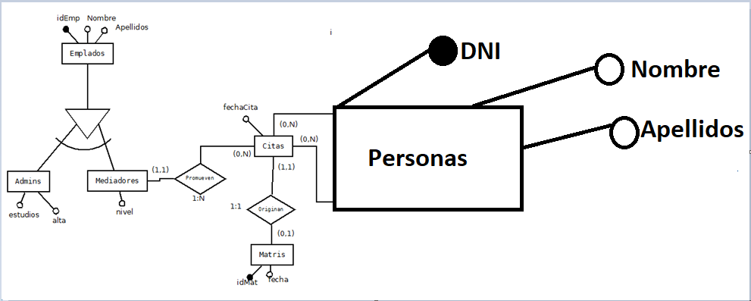

Aitor’s Answer

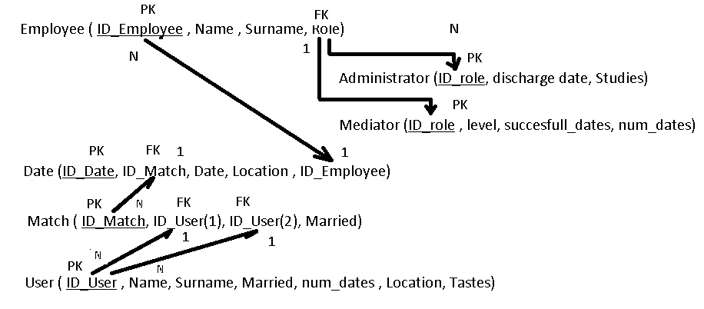

**2nd Exercise (25% of the control)**

The following table is not in 1NF.

Create a relational graph in which the resulting tables are in 3rd FN.

|  |  |  |  |  |  |  |
| --- | --- | --- | --- | --- | --- | --- |
| **pet_id** | **pet_name** | **Species** | **Age** | **Owner** | **Date** | **Treatment** |
| 246 | ROVER | DOG | 12 | SAM COOK | 1/13/2002  3/27/2002  4/2/2002 | Rabies vaccination  Routine exam  Worm test |
| 298 | SPOT | DOG | 2 | TERRY KIM | 1/21/2002  3/10/2002 | Tetanus vaccination  Worm test |
| 341 | MORRIS | CAT | 4 | SAM COOK | 1/23/2001  1/23/2002 | Rabies vaccination  Rabies vaccination |
| 519 | TWEEDY | BIRD | 2 | TERRY KIM | 4/30/2002  4/30/2002 | Annual check up  eye cleaning |

**Aitor’s Answer**

**Yellow been the Primary Key**

|  |  |  |  |
| --- | --- | --- | --- |
| **ID_ap** | **Date** | **ID_pet** | **ID_Treat** |
| 1 | 1/23/2001 | 341 | 1 |
| 2 | 1/13/2002 | 246 | 1 |
| 3 | 1/21/2002 | 298 | 4 |
| 4 | 1/23/2002 | 341 | 1 |
| 5 | 03/10/2002 | 298 | 3 |
| 6 | 3/27/2002 | 246 | 2 |
| 7 | 04/02/2002 | 246 | 3 |
| 8 | 4/30/2002 | 519 | 5 |
| 9 | 4/30/2002 | 519 | 6 |

|  |  |
| --- | --- |
| **ID_treat** | **Treatment** |
| 1 | Rabies vaccination |
| 2 | Routine exam |
| 3 | Worm test |
| 4 | Tetanus vaccination |
| 5 | Annual check up |
| 6 | eye cleaning |

|  |  |  |  |  |
| --- | --- | --- | --- | --- |
| **ID_Pet** | **ID_Species** | **Pet_Name** | **Age** | **Owner** |
| 246 | 1 | ROVER | 12 | SAM COOK |
| 298 | 1 | SPOT | 2 | TERRY KIM |
| 341 | 2 | MORRIS | 4 | SAM COOK |
| 519 | 3 | TWEEDY | 2 | TERRY KIM |

|  |  |
| --- | --- |
| **ID_species** | **Name** |
| 1 | Dog |
| 2 | Cat |
| 3 | Bird |